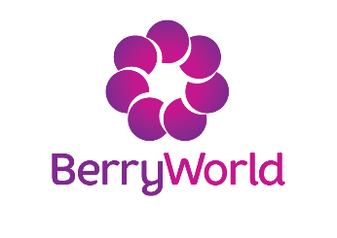
Please sign below to indicate that you have read and understood the Privacy and Data Protection Notice in the application information and to show that you understand how your personal data will be processed in connection with your scholarship application.

I have read and understood the Privacy and Data Protection Notice:

Full Name: Student ID:

Course: Signature:

Date:

You can type your name in the signature box and this will be accepted as an electronic signature

Save your completed and signed form as a PDF and upload it with your letter and CV

