

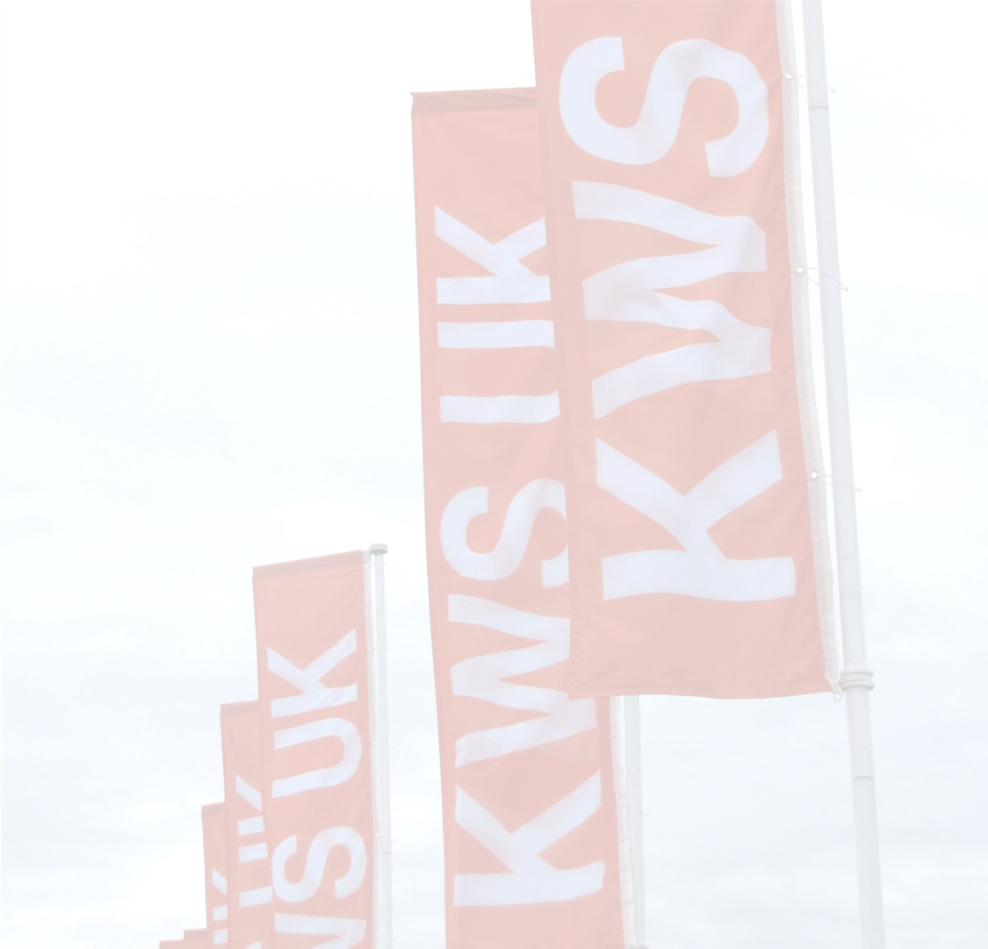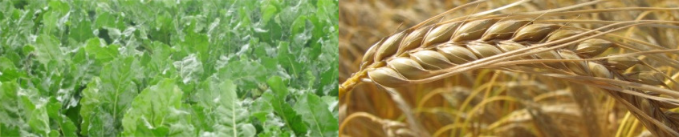

**Who can apply?**

The KWS UK Scholarship is open to all **2nd year BSc** or **1st year FdSc** students studying **Agriculture** at Harper Adams who are **interested in knowing more about a career in plant breeding**.

**Opportunities**

The company may award one scholarship, and if awarded the successful scholarship recipient will receive:

* A payment of **£2,500** in the academic year awarded.
* Employment with KWS UK during their placement year.
* Subject to a review at the end of the placement with KWS UK, there may be an opportunity of further funding in the scholar’s ﬁnal academic year.

The award will be paid in two equal parts; half to be paid in February 2017 and the remaining balance in May 2017.

Payment is conditional on the scholar remaining registered as a full-time student at Harper Adams. They must pass all modules of study during the continuation of the scholarship and submit at least one written report to the Development Trust prior to the receipt of their second payment. A condition of your scholarship is that you undertake your placement year with KWS. In the event you are unable to take up or complete your placement, the sponsor reserves the right to require the scholar to return all or part of any scholarship payment received.

This is a competitive award which will be evaluated on the merit of the submitted application, academic achievements to date and interview. The decision of the KWS UK Scholarship Panel is **FINAL** and they reserve the right to withdraw the award at any time should they feel this action is required.

*Shortlisted applicants will be invited for interview with KWS UK.*

# Application Process

On A4 paper, no more than 2 pages, **font NO smaller than Arial 11)**, please explain why you would be interested in receiving the KWS UK Scholarship.

**Please include the following information:**

1. Why you have selected your chosen course.
2. Why you are interested in plant breeding.
3. What contributions you would bring to our team.
4. What you hope to achieve and how this would contribute towards your future career.
5. Information about yourself – interests, hobbies etc.
6. A brief CV - **maximum of 2 pages** and **Font Size Arial 11 or larger**.

**Please note - you may ONLY apply for a maximum of 3 placement based scholarships**

**Should your application be successful you will be required to decide whether or not to accept the scholarship offered within 24 hours; failure to do so in the designated time period may result in the offer being withdrawn by the sponsor.**

# 



# 

# In the event that KWS UK requests UCAS and/or academic information to assess your application, your authorisation and signature are required. In addition, this allows HAU and the sponsor to publicise your scholarship.

# Please indicate this below.

I authorise HAU to use my information in accordance with the above:

Name: ______________________________ Student ID: _________________________________

Signature: ____________________________ Course Title: _________________________________

**Because the KWS UK Scholarship includes a placement you must submit your application through the following website:**

[**http://harper.ac.uk/placements**](http://harper.ac.uk/placements)**.**

**Deadline for Submission of Application: 9am Monday 07 November 2016**

Please note that you **MUST** submit your application via the above website

Paper copies will not be accepted for placement linked scholarships.